ANALYSIS OF GEOGRAPHIC AND HISTORICAL POTENTIAL OF TUMPAK RINJING MONUMENT AND ITS URGENCY AS A SOURCE OF HISTORICAL LEARNING
Wahyu Djoko Sulistyo, Moch. Nurfahrul Lukmanul Khakim, Bayu Kurniawan, Nabilatus Saidah
Jurusan Sejarah, Fakultas Ilmu Sosial, Universitas Negeri Malang.
Jl. Semarang 5, Malang 66145, Telepon. 0341-585966
Wahyu.djoko.fis@um.ac.id

Abstrak: This article describes the analysis of the geographical and historical potential of the Tumpak Rinjing Monument, located in the district of Pacitan as one of the memorials to historical events during the struggle for the physical revolution in Indonesia. Furthermore, this article also describes the urgency analysis of monuments as a source of local-based learning, especially for history learning. The method used is a historical and qualitative method with the type of research carried out is field research. The main finding in this study is that the geographical and historical potential of the existence of a hand-over batch monument is very supportive as a source of learning and learning.
Keywords: Tumpak Rinjing Monument, geographical, historical potential, urgency, Pacitan

INTRODUCTION
Learning local history is one of the learning innovations that can be applied in Indonesia. This learning innovation leads more to the mastery of material strategies by making events, relics and local histories as objects. Speaking of local history means speaking of certain geographical spatial aspects, and Indonesia is rich in that (Abdullah, 1985; Priyadi & Nursam, 2012). More specifically, according to (Widja, 1991) local history is a form of writing history in a limited scope that includes a certain locality, so the limitations of that scope are mainly usually associated with regional or spatial elements. Learning local history emphasizes aspects of environmental awareness from an early age. This is so that learning does not only revolve around textbooks or material that is only given by the teacher. To explore more deeply, local histories need to be studied in more detail. By adopting an environmentally conscious attitude, students are expected to be able to study the local histories that exist around their respective lives (Amin, 2010). The result later, learning will be far more detailed because the material obtained is more weighted with more accurate data.
Based on Indonesia's very complex historical history (Abdullah, 1990), local history learning strategies are very likely to be used. This is because important events in the historical history of the Indonesian people did not only occur in one large area but also occurred in remote places though. Local history is a diverse color in every civilization (Aston, 2002; Hoskins & Hey, 2014) Therefore, learning by looking at geographical and historical potential is very necessary. Each region in Indonesia certainly has a different geographical location and historical study (Robinson, 1953; Rustiadi, 2018; Utoyo, 2009). By relying on the diversity of potential and historical, all should be able to contribute together to improve mastery of local-based material or learning (Sulistyo, Nafi'ah, & Idris, 2019).
However, today's young generation may be in an unfortunate situation. The swift current of globalization creates a generation of young Indonesians who neglect the nation's culture and are more concerned with tracing foreign cultures (Agustin, 2011; Suneki, 2012). Homeland love can be said to have thinned from within every teenager. Education in schools is only a formality carried out by every citizen since childhood living in Indonesia. It can be concluded that locally-based learning is very important to be improved. Therefore in this study will reveal the geographical and historical potential of the existence of an identical monument to local historical events, so that it can be used as a source of learning and learning.
METHOD
The method used in writing this article is the historical method or writing method by historical conventions. Historical research is a problem-solving procedure using past data or relics both to understand events or a situation that took place in the past regardless of present circumstances about events or the past, then often the results can also be used to predict events or future circumstances. It can be concluded that the historical method uses data and past relics as research objects (Dudung, 2007; Kuntowijoyo, 2003; Richardson & Culloch, 2000). In addition to the historical method in this study also uses a qualitative approach to collect field data, both through observation, interviews and source analysis (Creswell & Creswell, 2017; Denzin & Lincoln, 2008; Hay, 2000). The object of this research is a monument in sub-district of Pringkuku, District of Pacitan, East Java, Indonesia. The historical analysis was carried out to see the historical background of the existence of moneymen who featured statues of two major figures in history in Indonesia namely Soedirman and Supriyadi. As for the analysis of geographical potential is to look at aspects of the area, access to location and surrounding communities so that it supports to place this monument as a vehicle for learning and learning resources. Next is the technique or method of data collection. The first thing to do was an interview with Mbah Misno, a former head of Dadapan whose house also coincided in front of the Tumpak Rinjing Monument. After the interview, the next data collection procedure is documentation.
RESULT AND DISCUSSION
- Geographical Potential Regional Establishment of Tumpak Rinjing Monument

Tumpak Rinjing Monument was erected in Dadapan Village, Pringkuku District, Pacitan Regency. This monument is located right on the edge of the road so that it can be easily seen by motorists who pass through the road. However, this monument is one of the historical sites that are rarely visited and poorly maintained. This is caused by many factors that make the Camping Rump become a forgotten historical site. Judging from its geographical factors, this monument has extraordinary potential. This is caused by the location where the Tumpak Rinjing Monument was founded.
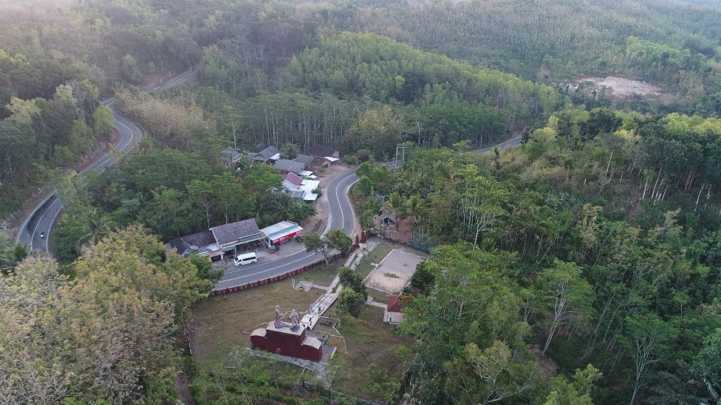
Picture 1. Geographical imagery around the Monument seen from up (Private doc, 2019)

Dadapan Village is a village where the Tumpak Rinjing Monument was built. The location of this village is 7 km to the south of the center of Pringkuku District with a total area of ​​837 hectares (BPS Kab Pacitan, 2018). Dadapan village has a special area of ​​9.9 hectares for buildings or settlements and 141.28 hectares for farm or garden. As for community forests and plantations, the area is 540.60 hectares. The boundaries of the area are as follows: the north is the Village of Ngadirejan and Pringkuku, the east is the Village of Sidoharjo, the west is the Village of the Principal, while the south is the Indonesian Ocean.
Based on the fact that the demographics of the Dadapan village are dominated by plantations and community forests, the livelihoods of the residents of Dadapan are mostly farmers. Some of the crops produced by Dadapan Village are rice, corn, soybeans, peanuts, eggplants, spinach, avocados, guavas, lime oranges, and so on. Besides, the geographical location of Dadapan Village which is close to the territorial waters of the Indonesian Ocean also provides diverse tourism potential. One of them is Sentono Gentong, a tourist spot that can be found in the village of Dadapan that offers extraordinary views from a height. The view that can be seen from this place is Teluk Pacitan, white sand of Teleng Ria Beach to Pancer Dor Beach (Kompas.com, 2018).
So much potential can be utilized from Dadapan Village and its surroundings. This also applies to the district, district, to the city. It cannot be denied anymore, Pacitan is indeed a high potential area. Starting from the geographical potential to the potential for tourism and history. Therefore, among the many things that exist in Pacitan, do not be surprised if historical relics are also found here. One of them is the Tumpak Rinjing Monument which is located in Dadapan Village, Pringkuku District, Pacitan Regency.
The location of the Tumpak Rinjing Monument was built in a strategic place. The distance between this monument and the city center, Pacitan Square is 9.5 km, can be recovered at a normal speed in about 15 minutes. No need to trouble finding the location of the Tumpak Rinjing Monument, because this monument is located right on the edge of the road so it will be easily seen when passing through it. The standing area of ​​the Tumpak Rinjing Monument is in the middle of a grassy field. Bounded by a red fence with a bathara symbol when it surrounds it, the area of ​​this monument looks neatly arranged from the outside. However, actually, the area of ​​the Tumpak Rinjin Monument is quite poorly maintained because the Pacitan regional government prioritizes taking care of the tourism potential rather than the history.
2. Historical Potential of Tumpak Rinjing Monument
Behind its beauty as one of the most beautiful cities with all its legendary tourism potential, this city also has another potential that is no less captivating. Pacitan City is one of the most historic places in Indonesia. The historical history of this city is very diverse, starting from the remnants of the past, ancient human fossils, to the former struggle of the Indonesian people in fighting the invaders, all of which can be traced in the city of Pacitan. No wonder the tourist attractions of Pacitan are very diverse, ranging from the beaches that stretch across the southern Pacitan, historic caves from ancient human relics, to historical places of the former legacy of the struggle in various directions in the city of Pacitan.
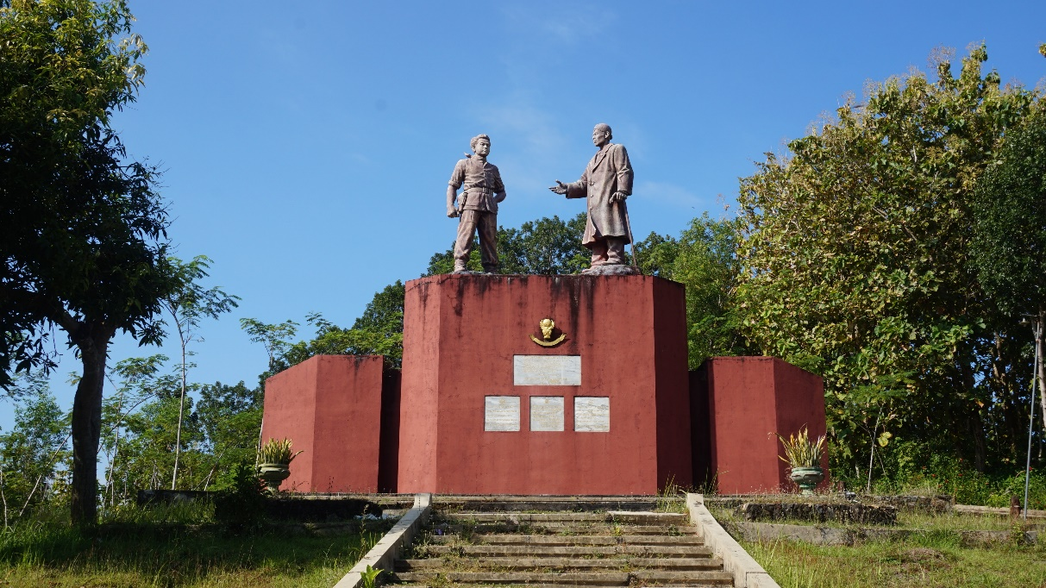
Picture 2. Tumpak Rinjing Monument visible from the front side (Private Doc., 2019)

One historical legacy of the struggle in the city of Pacitan was when the Dutch Military Aggression occurred in 1948. An attempt was made again by the Dutch to regain Indonesia by attacking the capital of Yogyakarta (Dekker, 1980; Nasution, 1991; Sapto, 2015; Setyohadi, 2002). This event also left its mark on Pacitan. The city was passed by General Soedirman and his troops in carrying out guerrilla routes. General Soedirman's troops in their struggle against the Dutch stopped in the city for some time. No wonder then in various corners of the city, you can find the monuments of General Soedirman along with his halfway houses. Among one of these places, there is one in Dadapan Village, Pringkuku District, Pacitan Regency. That place is the Tumpak Rinjing Monument. Even though the general never stopped at this place, the people's resistance that had taken place here was proof that the whole struggle of the general to refuse submission was supported by the people.
The construction of the Tumpak Rinjing Monument in the Dadapan Village of Pacitan Regency is proof that history has ever stopped in this city. This monument is one of the historic sites in Pacitan which was built to commemorate the struggle of General Soedirman and his troops against the Dutch. There are still many things that are not yet known about the true history behind the built of the monument. Even though the Tumpak Rinjing Monument was built with the statue of General Soedirman on it as the main part, in fact, he could be considered not too involved in the incident that occurred in the village of Dadapan where the monument was built.
The statue located above the Tumpak Rinjing Monument is a statue of General Soedirman and Slamet Riyadi, the monument is not only meaningful to commemorate General Soedirman's services in leading troops against the Dutch, but also to commemorate the services of Sahid, a Hansip (local security) from Yogyakarta who had to die in Pacitan land to against the Dutch army, precisely during the 1948 Dutch Military Aggression (Interview with Mbah Misno, 71 years).
- The Importance of Tumpak Rinjing Monument as a Learning Resource
After seeing the geographical and historical potential of the Tumpak Rinjing Monument, it can be said that this monument has many features. Especially in terms of making monuments or relics of the past as a source of historical learning by utilizing the local potential. The following are the benefits of these uses:
- Giving birth to superior and characterless generations
Local-based learning is expected to shape the character of the younger generation into a superior generation. Not only great at accessing all information with sophisticated technology, but the younger generation is also expected to master local-based learning (Yunus, 2013). This is intended so that the sense of caring for the environment and cultural love will be enhanced. By making the Tumpak Rinjing Monument a local-based learning resource, students are expected to be competent in mastering material by never forgetting their local culture or history. The Tumpak Rinjing Monument, for example, can hone the ability and character of the nation in learning how the history that occurs in the area around the monument or the area of ​​the monument is erected, which if traced through the internet is still difficult to find. The internet is not everything. The balance between technological sophistication and local culture must be considered, especially for the young generation of the nation.

- Reflecting local cultural values ​​and preserving national culture
Based on the concept of cultural sites proposed by Olwig and Hastrup there is an important relationship between place and space (Olwig, 2005; Stockton & Holland, 1974). This concept more clearly intends to explain that the process of adaptation to new cultures, like a current culture that has developed rapidly, is not recommended to forget the old culture. By making the Tumpak Rinjing Monument as one of the sources of local learning, it is hoped that, although history learning has become accustomed to sourced in textbooks and only focuses on browsing material instantly through the internet, it is inevitable that the cultural values ​​that are around, in this case, Tumpak Rinjing Monument must not be ignored. By keeping abreast of the times, the reflection of cultural values ​​from the Tumpak Rinjing Monument must also continue.
Preservation of the nation's culture has become an obligation for all Indonesian people. Too spoiled by today's technology makes the love of the motherland slowly disappear and a sense of ignorance arises. Making historical relics as a source of local-based learning will foster a love for the nation's culture and can slowly preserve the nation's culture. Ironically, the historical relics that should have been a treasure for the Indonesian people are always prioritized for attention. Lack of maintenance, damage to buildings, loss of data, etc. have been commonplace in various historical relics. A lack of interest in caring for objects like this is very alarming. It is hoped that by making the Tumpak Rinjing Monument one of the sources of local learning, it can increase the love of the motherland and still preserve the nation's culture.

- Contribute to creating a national identity
Making the Tumpak Rinjing Monument as one of the sources of local-based learning can indirectly manifest a national identity and nationalism. Nationalism is important to be taught in history learning as a form of character education (Khakim, 2014). In Indonesia, the Tumpak Rinjing Monument stands firmly aimed at showing historical events that are important to remember and emulate. There was a struggle of the people of Pacitan and General Sudirman in it which later became the identity of the Indonesian people as a country full of struggle and sacrifice. Without the help of the younger generation to pay more attention to local culture and the love of the motherland, this monument, even with other historical relics will not have a profound meaning.
CONCLUSION
Geographical potential can be seen in the area where the Tumpakrinjing Monument stands. Territorial conditions in the village of Dadapan, Kec. Pringkuku, Pacitan Regency is topographically included in a mountain range of a thousand south sides of Java Island. Its location at a certain height point from the limestone hills also offers the potential of geo-tourism in the form of an extraordinary natural landscape with the Indonesian ocean landscape on the south side. The location of the construction of the Tumpak Rinjing Monument is in a strategic place. The distance between this monument and the city center, Pacitan Square is 9.5 km, can be recovered at a normal speed in about 15 minutes. No need to trouble finding the location of the Tumpak Rinjing Monument, because this monument is located right on the edge of the road so it will be easily seen when passing through it. So it is very easy to access and visit both in the context of learning the history and traveling.
Potensi historis dengan jelas diuraikan bahwa monumen ini sebagai bukti terjadinya sebuah bentuk perlawanan bangsa Indonesia terhadap aksi penjajahan kembali yang dilancarkan oleh Belanda. Keteladanan tokoh juga dapat dipelajari dari monument ini mengingat sosoh patung yang berada di monument ini adalah tokoh besar dalam sejarah bangsa yaitu Jenderal Soedirman dan Slamet Riyadi. Urgensi dari pemanfaatan monument ini sebagai sumber belajar sejarah yang pertama karena secara geografis sangat mudah untuk diakses dan dijangkau. Kedua sebagai bentuk dari pemanfaatan potensi lokal embelajaran berbasis lokal daerah dengan segala kebermanfaatanya yang masih sangat relevan bagi anak generasi sekarang ini.
REFERENCES
Wawancara dengan Pak Misno. Tanggal 20 Mei 2019.

