STRUCTURAL ANALYSIS OF SUCCESS FACTORS OF SMALL MEDIUM BUSINESS (UKM) USING INTERPRETATIVE STRUCTURAL MODELING (ISM) APPROACH IN BUNGARAYA SUB-DISTRICT

*Auliya Rahmi¹, Iswandi Umar²
Student of Master Program of Geography Education, Universitas Negeri Padang (UNP), Indonesia¹
Lecturer of Master Program of Geography Education, Universitas Negeri Padang (UNP), Indonesia²
E-mail: auliyarahmi60@guru.sma.belajar.id

*Corresponding Author, Received: August 20, 2022. Revised: Nov 21, 2022. Accepted: Dec 26, 2022

ABSTRACT : The aims of this research were: 1) to know the structural modeling to know the priorities (key factors) and supporting factors in the success factors of a UKM, 2) to know the solutions that can be suggested when the key success factors for UKM are known. The design of this study is qualitative research in the form of expert opinion that has had successful SMEs. The research began with interviews and giving questionnaires to representatives of each UKM, the number of UKM studied in this study was 4, so the total number of experts interviewed and given questionnaires were also 4 people. SMEs that contributed to this research was in the culinary field. The name of the UKM is Sate Pariaman, RM. Surabaya, My Mama's Kitchen 3B, and Ipat restaurant. Where is this study, using expert judgment using the VAXO questionnaire in collecting data? In data processing in this software, researchers use EXIMPRO – ISM.exe software. Based on the results of the structure, it can be seen in order of sub-elements with the highest ranking, namely Market Demand (E11) as the key factor influencing the success of SMEs. Then the second rank is Own Capital (E5), and the third rank has 21 elements namely Motivation (E1), Formal Education Level (E2), Experience (E3), Entrepreneurial Spirit and Leadership (E4), Loan Capital (E6), Profit Level and Capital Accumulation (E7), Financial Governance (E8), Production Capacity (E9), Modern Technology and Quality Control (E10), Technology Selection (E12), Market Demand (E13), Competitive Pricing (E14), Promotion (E15 ), Distribution Channels and Marketing Areas (E16), Business and Investment Climate (E17), Lots of Competition in the Same Field (E18), Economic Growth (E19), Community Income Level (E20), Capital Assistance from Related Institutions (E22), There is Technical Guidance (23), Monitored and Evaluation (E24). The last ranking is Government Policy (E21).

Keywords: Success Factors, UKM/ SMEs, ISM, Bungaraya Sub-District.

- INTRODUCTION
Many national and world social and economic scientists have the same opinion regarding the economic crisis due to a pandemic different from the 1998 and 2007 crises, the impact of the pandemic covered all business actors while the two previous crises did not have an impact on Small and Medium Enterprises (SMEs), even SMEs can still be a lifeline for the Indonesian economy, this opinion was also expressly conveyed by Sri Mulyani, Minister of State Finance (Chittithaworn, 2021).
The SMEs are an important part of the economy of a country or region, as well as Indonesia. SMEs have a very important role in the pace of the community's economy. SMEs also help the state or government in terms of creating new jobs and through SMEs also create many new work units that use new workers who can support household income, the Office of Cooperatives and SMEs in Siak Regency 2016-2018 recorded 263. Meanwhile, in the Bungaraya sub-district, there were a total of 13 SMEs in 2018. One example of a UKM commodity that is currently rife in UKM competition in Bungaraya is the UKM commodity in the food sector.
Several previous studies that linked an element included the research used by Wan et al (2013) which discussed how the interrelationships between factors in the success/keys to the success of the mobile internet used ISM.
Therefore, in knowing the interrelationships of success factors in a UKM this researcher will use an Interpretive Structural Modeling (ISM) approach to model the linkages between these factors in a structured way so that they can be used as material for evaluating UKM to further improve UKM performance by knowing the main linkages these factors. To determine policy directions, use the ISM. The ISM method is very effective for structuring very complex problems, explaining problems, and determining causal relationships. In determining the contextual relationship between elements, it is determined based on expert opinion. Several considerations in determining research experts are: 1) having experience in the field being studied; 2) having a reputation or competence in the field under study; and 3) having high credibility in the studied field.

- METHODS
The design of this study is qualitative research in the form of expert opinion which has been a relatively successful UKM. The research began with interviews and giving questionnaires to representatives of each UKM, the number of UKM studied in this study was 4, so the total number of experts interviewed and given questionnaires were also 4 people. Representatives of each UKM are experts or experts who have an important role in establishing the business such as the owner or founder (owner), manager, administrator, or head of the section. SMEs that contributed to this research was in the culinary field. The name of the UKM is Sate Pariaman, RM. Surabaya, My Mama's Kitchen 3B, and Ipat restaurant.
This research was conducted in Bungaraya sub-district, Siak Regency, Riau Province (Fig 1). The time of research is 2022.

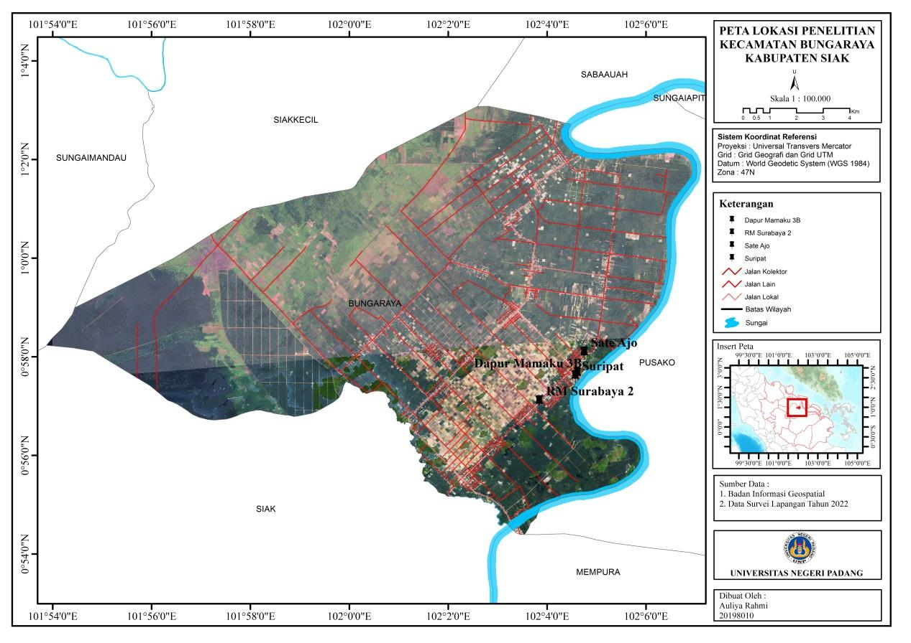

Figure 1. Research Locations (In Indonesia)

The conceptual model of the second part of this research is research conducted by Rimantho & Rosdiana (2017) to determine the key factors for improving the quality of wastewater in the food industry using Interpretative Structural Modeling (ISM). Where the research used expert judgment using the VAXO questionnaire in collecting data. Similar to the research that will be carried out, Rimantho&Rosdiana use the opinion of more than 1 expert as the object of their research, then the results of the questionnaire are processed using EXIMPRO – ISM.exe software. In making the questionnaire, the researcher made a questionnaire with the concept of comparing the relationship between 1 factor and other factors in the success of SMEs. Respondents were asked to choose the relationship between these factors according to the options available, as follows:
V = the presence of variable I achieves/triggers the presence of variable j
A = presence of variable i is achieved/triggered by the presence of variable j
X = variable I and variable j trigger each other to achieve
O = variable I and variable I are not related

3. RESULTS
3.1 Description of UKM RM Surabaya
RM Surabaya is a small business that started with a simple diner located on Jalan Hang Tuah, Bungaraya sub-district, Siak Regency. Starting from an owner who likes to eat meatballs and likes to cook hodgepodge and get a location in the middle of rice fields with beautiful views, he finally decided to open an RM Surabaya business in Bungaraya sub-district, initially, this business was sold enthusiastically by very good visitors marked by being filled with visitors everyday. With a line of business, namely Food which was founded in February 2007 by Chair Maryadiani. The concept of presenting Indonesian food has a taste quality that is different from other places to eat. The raw materials used are raw materials available in the market and farmers in Bungaraya sub-district. RM Surabaya proves that a business that starts small can become a successful UKM because it already has 2 branches with various employees. RM Surabaya is also a family business because it is managed directly by the children and grandchildren of the owner
.
Sate Pariaman
Sate Pariaman is a culinary food business with owners who are native Pariaman people who have been around since June 2010 by AjoManih. This business was created initially by traveling around using a wheelbarrow and even today the owner is still running his business using a wheelbarrow which is now at a crossroads in Bungaraya Village. Sate Pariaman now has 5 branches, each of which has been developed by their children, in-laws, and grandchildren. Usually bought children selling around the markets and other places.
Kitchen Mamaku 3B
Kitchen Mamaku 3B is a cake-making business that was founded in early 2008 by Mrs. ArikIndrayani who is an elementary school teacher in a school in Bungaraya sub-district. Businesses in the field of Food &, this Bakery produces and distributes its cakes in the Bungaraya area and its surroundings. Various kinds of cakes are sold, from birthday cakes, wedding cakes, and market snacks, to taking orders for box cakes for events. The production house from DapurMamaku 3B itself is carried out at the owner's residence so until now it has several employees, and the busiest time is the time for Eid al-Fitr and Eid al-Adha because there are so many Eid cake orders. Kitchen Mamaku 3B 2022 will receive assistance with a baking tool from the relevant government agency which aims to develop the business he has been running. Maintain product quality. The owner of Mamaku Kitchen 3B said that he always provides the best and most professional service to meet customer satisfaction, creates and develops innovative and quality products at competitive prices, and always tries to increase the number of distribution channels so that they can develop more.

Ipat Rumah Makan
Ipat this restaurant was founded by Mrs. Suripat and her husband, which has been established since 2006 and started as a small shop selling side dishes every day. The owner of this restaurant provides raw materials directly from farmers in the Bungaraya sub-district and is cooked directly by the owner. Now, this restaurant is the oldest in Bungaraya sub-district with a wide variety of food, affordable prices, and large portions.
3.2 Questionnaire results
The second stage is filling out the questionnaire, based on the factors that have been fixed, respondents are given a questionnaire about giving a scale of correlation between 1 factor and other factors. The number of respondents in this study was 4 people, where each UKM was represented by 1 expert with a minimum of up to the founder/owner. The following is the gender recapitulation data of 4 experts & respondents/experts from this study.

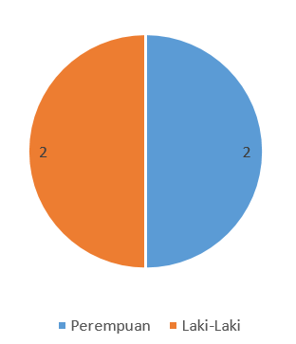
Figure 2. Recapitulation of Expert Gender

Based on the figure above, it can be seen that of the 4 experts in this study, 2 were male and 2 were female. In this section, after the respondents filled out the questionnaire, the researcher converted the answers from the VAXO questionnaire into a table of questionnaire results. The following are the results of the questionnaire for each respondent:

Respondents UKM "RM.SURABAYA"
Table 1. Questionnaire Results Respondent 1
NO | A1 | A2 | A3 | A4 | A5 | A6 | A7 | A8 | A9 | A10 | A11 | A12 | A13 | A14 | A15 | A16 | A17 | A18 | A19 | A20 | A21 | A22 | A23 | A24
A1 |  | X | X | V | A | V | A | X | X | V | X | V | A | A | X | A | A | A | O | A | A | V | A | A
A2 |  |  | O | X | A | O | O | V | O | V | X | V | O | V | V | O | A | A | O | O | A | O | O | O
A3 |  |  |  | A | A | X | A | X | X | A | X | X | X | X | X | X | A | A | X | O | A | X | X | X
A4 |  |  |  |  | A | V | O | V | A | V | O | V | V | V | V | A | A | A | A | A | _ | V | X | X
A5 |  |  |  |  |  | V | V | V | V | V | O | V | V | V | V | V | A | A | V | V | A | V | V | V
A6 |  |  |  |  |  |  | A | A | A | V | X | V | A | V | V | A | A | A | A | A | _ | V | O | V
A7 |  |  |  |  |  |  |  | A | X | V | O | V | A | V | V | _ | A | A | A | A | A | A | V | V
A8 |  |  |  |  |  |  |  |  | A | V | O | V | X | V | X | X | A | A | A | O | A | V | V | V
A9 |  |  |  |  |  |  |  |  |  | A | X | V | A | V | V | V | A | A | X | A | A | A | A | A
A10 |  |  |  |  |  |  |  |  |  |  | X | V | A | V | V | A | A | A | A | A | A | A | V | V
A11 |  |  |  |  |  |  |  |  |  |  |  | O | X | O | O | X | A | A | X | O | X | X | X | X
A12 |  |  |  |  |  |  |  |  |  |  |  |  | A | V | V | A | A | A | A | A | A | A | V | V
A13 |  |  |  |  |  |  |  |  |  |  |  |  |  | V | A | A | A | A | X | X | A | O | O | V
A14 |  |  |  |  |  |  |  |  |  |  |  |  |  |  | O | V | A | A | A | A | A | O | V | V V
A15 |  |  |  |  |  |  |  |  |  |  |  |  |  |  |  | A | A | A | V | X | A | A | A | A
A16 |  |  |  |  |  |  |  |  |  |  |  |  |  |  |  |  | A | A | V | A | A | X | V | V
A17 |  |  |  |  |  |  |  |  |  |  |  |  |  |  |  |  |  | V | V | V | V | V | V | V
A18 |  |  |  |  |  |  |  |  |  |  |  |  |  |  |  |  |  |  | V | V | V | V | V | V
A19 |  |  |  |  |  |  |  |  |  |  |  |  |  |  |  |  |  |  |  | A | A | V | A | A
A20 |  |  |  |  |  |  |  |  |  |  |  |  |  |  |  |  |  |  |  |  | A | A | X | V
A21 |  |  |  |  |  |  |  |  |  |  |  |  |  |  |  |  |  |  |  |  |  | V | V | A22
X |  |  |  |  |  |  |  |  |  |  |  |  |  |  |  |  |  |  |  |  |  |  | X | X
A23 |  |  |  |  |  |  |  |  |  |  |  |  |  |  |  |  |  |  |  |  |  |  |  | A24
SME

70
Respondents “SATE PARIAMAN”
Table 2. Respondent Questionnaire Results 2
NO | A1 | A2 | A3 | A4 | A5 | A6 | A7 | A8 | A9 | A10 | A11 | A12 | A13 | A14 | A15 | A16 | A17 | A18 | A19 | A20 | A21 | A2 2 | A23 | A24
A1 |  | V | X | X | V | V | X | A | X | V | O | A | A | V | V | A | X | X | V | A | A | A | A | V
A2 |  |  | X | X | V | O | V | V | V | V | O | X | O | X | A | A | X | X | V | A | A | X | X | V
A3 |  |  |  | X | V | V | X | V | A | V | O | V | V | V | A | V | X | A | A | V | A | X | X | X
A4 |  |  |  |  | V | V | V | V | V | V | O | V | V | V | X | _ | X | A | A | A | A | V | V | O
A5 |  |  |  |  |  | A | A | A | A | A | O | A | A | A | A | A | A | A | A | A | A | A | A | _
A6 |  |  |  |  |  |  | V | A | X | O | O | A | V | V | A | O | O | X | A | V | A | O | A | A
A7 |  |  |  |  |  |  |  | V | V | A | O | X | X | O | V | A | A | V | O | A | A | A | A | O
A8 |  |  |  |  |  |  |  |  | V | O | O | X | V | V | A | A | V | V | X | O | A | A | A | O
A9 |  |  |  |  |  |  |  |  |  | X | O | A | X | O | O | V | A | V | X | X | A | O | A | V
A10 |  |  |  |  |  |  |  |  |  |  | O | X | V | V | A | O | O | X | A | V | A | A | A | A
A11 |  |  |  |  |  |  |  |  |  |  |  | O | O | O | O | O | O | O | O | O | A | O | O | O
A12 |  |  |  |  |  |  |  |  |  |  |  |  | A | O | X | A | A | A | A | O | A | A | A | A
A13 |  |  |  |  |  |  |  |  |  |  |  |  |  | V | X | V | A | V | V | A | A | A | O | O
A14 |  |  |  |  |  |  |  |  |  |  |  |  |  |  | X | A | X | A | V | X | A | O | O | O
A15 |  |  |  |  |  |  |  |  |  |  |  |  |  |  |  | X | A | A | A | A | A | A | A | A
A16 |  |  |  |  |  |  |  |  |  |  |  |  |  |  |  |  | V | V | V | V | A | A | A | A
A17 |  |  |  |  |  |  |  |  |  |  |  |  |  |  |  |  |  | V | A | A | A | X | A | V
A18 |  |  |  |  |  |  |  |  |  |  |  |  |  |  |  |  |  |  | X | A | A | X | X | X
A19 |  |  |  |  |  |  |  |  |  |  |  |  |  |  |  |  |  |  |  | X | A | V | V | V
A20 |  |  |  |  |  |  |  |  |  |  |  |  |  |  |  |  |  |  |  |  | A | A | V | X
A21 |  |  |  |  |  |  |  |  |  |  |  |  |  |  |  |  |  |  |  |  |  | V | V | V
A22 |  |  |  |  |  |  |  |  |  |  |  |  |  |  |  |  |  |  |  |  |  |  | V | V
A23 |  |  |  |  |  |  |  |  |  |  |  |  |  |  |  |  |  |  |  |  |  |  |  | X
A24
71
Respondents to UKM “DAPUR MAMAKU 3 B”
Table 3. Questionnaire Results for Respondent 3
NO | A1 | A2 | A3 | A4 | A5 | A6 | A7 | A8 | A9 | A10 | A11 | A12 | A13 | A14 | A15 | A16 | A17 | A18 | A19 | A20 | A21 | A22 | A23 | A24
A1 |  | V | X | X | V | V | X | A | X | V | O | A | A | V | V | A | X | X | V | A | A | A | A | V
A2 |  |  | X | X | V | O | V | V | V | V | O | X | O | X | A | A | X | X | V | A | A | X | X | V
A3 |  |  |  | X | V | V | X | _ | A | V | O | V | V | V | A | V | X | A | A | V | A | X | X | X
A4 |  |  |  |  | V | V | V | V | V | V | O | V | V | V | X | _ | X | A | A | A | A | V | V | O
A5 |  |  |  |  |  | A | A | A | A | A | O | A | A | A | A | A | A | A | A | A | A | A | A | A
A6 |  |  |  |  |  |  | V | A | X | O | O | A | V | V | A | O | O | X | A | V | A | O | A | A
A7 |  |  |  |  |  |  |  | V | V | A | O | X | X | O | V | A | A | V | O | A | A | A | A | O
A8 |  |  |  |  |  |  |  |  | V | O | O | X | V | V | A | A | V | _ | X | O | A | A | A | O
A9 |  |  |  |  |  |  |  |  |  | X | O | A | X | O | O | V | A | V | X | X | A | O | A | V
A10 |  |  |  |  |  |  |  |  |  |  | O | X | V | _ | A | O | O | X | A | V | A | A | A | A
A11 |  |  |  |  |  |  |  |  |  |  |  | O | O | O | O | O | O | O | O | O | A | O | O | O
A12 |  |  |  |  |  |  |  |  |  |  |  |  | A | O | X | A | A | A | A | O | A | A | A | _
A13 |  |  |  |  |  |  |  |  |  |  |  |  |  | V | X | V | A | V | V | A | A | A | O | O
A14 |  |  |  |  |  |  |  |  |  |  |  |  |  |  | X | A | X | A | V | X | A | O | O | O
A15 |  |  |  |  |  |  |  |  |  |  |  |  |  |  |  | X | A | A | A | A | A | A | A | A
A16 |  |  |  |  |  |  |  |  |  |  |  |  |  |  |  |  | V | V | V | V | A | A | A | A
A17 |  |  |  |  |  |  |  |  |  |  |  |  |  |  |  |  |  | V | A | A | A | X | A | V
A18 |  |  |  |  |  |  |  |  |  |  |  |  |  |  |  |  |  |  | X | A | A | X | X | X
A19 |  |  |  |  |  |  |  |  |  |  |  |  |  |  |  |  |  |  |  | X | A | V | V | V
A20 |  |  |  |  |  |  |  |  |  |  |  |  |  |  |  |  |  |  |  |  | A | A | V | X
A21 |  |  |  |  |  |  |  |  |  |  |  |  |  |  |  |  |  |  |  |  |  | V | V | V
A22 |  |  |  |  |  |  |  |  |  |  |  | 72 |  |  |  |  |  |  |  |  |  |  | V | V
A23 |  |  |  |  |  |  |  |  |  |  |  |  |  |  |  |  |  |  |  |  |  |  |  | X
A24

Respondents to UKM “IPAT RESTAURANT”
Table 4. Results of Respondents Questionnaire 4
NO | A1 | A2 | A3 | A4 | A5 | A6 | A7 | A8 | A9 | A10 | A11 | A12 | A13 | A14 | A15 | A16 | A17 | A18 | A19 | A20 | A21 | A22 | A23 | A24
A1 |  | V | X | X | V | V | X | A | X | V | O | A | A | V | _ | A | X | X | V | A | A | A | A | V
A2 |  |  | X | X | V | O | V | V | V | V | O | X | O | X | A | A | X | X | V | A | A | X | X | V
A3 |  |  |  | X | V | V | X | V | A | V | O | V | V | V | A | V | X | A | A | V | A | X | X | X
A4 |  |  |  |  | V | V | V | V | V | V | O | V | V | V | X | V | X | A | A | A | A | V | V | O
A5 |  |  |  |  |  | A | A | A | A | A | O | A | A | A | A | A | A | A | A | A | A | A | A | A
A6 |  |  |  |  |  |  | V | A | X | O | O | A | V | V | A | O | O | X | A | V | A | O | A A | A
A7 |  |  |  |  |  |  |  | V | V | A | O | X | X | O | V | A | A | V | O | A | A | A | A | O
A8 |  |  |  |  |  |  |  |  | V | O | O | X | V | V | A | A | V | V | X | O | A | A | A | O
A9 |  |  |  |  |  |  |  |  |  | X | O | A | X | O | O | V | A | V | X | X | A | O | A | V
A10 |  |  |  |  |  |  |  |  |  |  | O | X | V | V | A | O | O | X | A | V | A | A | A | A
A11 |  |  |  |  |  |  |  |  |  |  |  | O | O | O | O | O | O | O | O | O | A | O | O | O
A12 |  |  |  |  |  |  |  |  |  |  |  |  | A | O | X | A | A | A | A | O | A | A | A | A
A13 |  |  |  |  |  |  |  |  |  |  |  |  |  | V | X | V | A | V | V | A | A | A | O | O
A14 |  |  |  |  |  |  |  |  |  |  |  |  |  |  | X | A | X | A | V | X | A | O | O | O
A15 |  |  |  |  |  |  |  |  |  |  |  |  |  |  |  | X | A | A | A | A | A | A | A | A
A16 |  |  |  |  |  |  |  |  |  |  |  |  |  |  |  |  | V | V | V | V | A | A | A | A
A17 |  |  |  |  |  |  |  |  |  |  |  |  |  |  |  |  |  | V | A | A | A | X | A | V
A18 |  |  |  |  |  |  |  |  |  |  |  |  |  |  |  |  |  |  | X | A | A | X | X | X
A19 |  |  |  |  |  |  |  |  |  |  |  |  |  |  |  |  |  |  |  | X | A | V | V | V
A20 |  |  |  |  |  |  |  |  |  |  |  |  |  |  |  |  |  |  |  |  | A | A | V | X
A21 |  |  |  |  |  |  |  |  |  |  |  |  |  |  |  |  |  |  |  |  |  | V | V | V
A22 |  |  |  |  |  |  |  |  |  |  |  |  |  |  |  |  |  |  |  |  |  |  | V | V
A23 |  |  |  |  |  |  |  |  |  |  |  |  |  |  |  |  |  |  |  |  |  |  |  | X
A24

73

After inputting the data from the questionnaire results, the data processing was carried out by Software EXIMPRO – ISM.exeRM value final which results in a Level, Ranking value then a sub-element classification is made according to the requirements of each sector as follows.

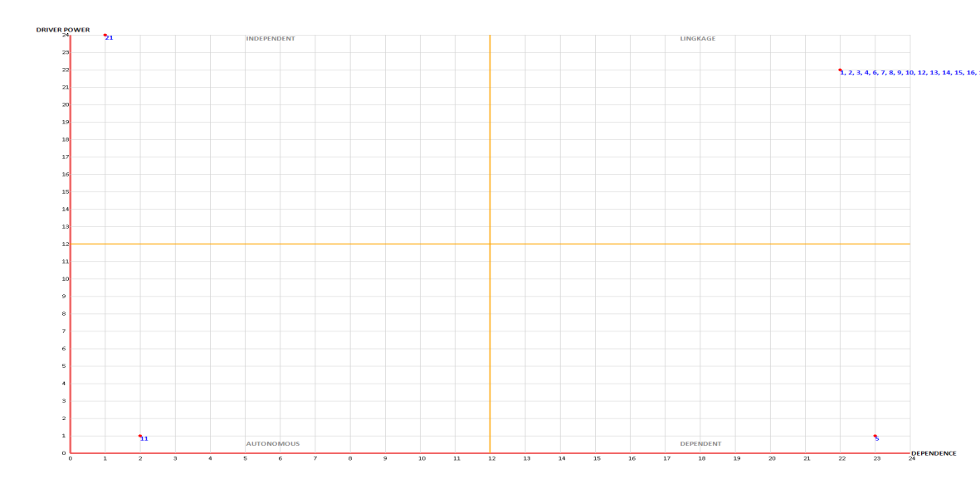
Figure 3. Sub-Element Classification

Based on Figure 13 it can be seen that of the 24 SME success factors, the classification of sub-elements that meet the requirements goes into all of them, namely 4 sectors. Sector 1 (Autonomous) has 1 factor, namely (E11), sector 2 (Dependent) has 1 (E5), sector 3 (Linkage) has 21 factors, namely (E1), (E2), (E3), (E4), ( E6), (E7), (E8), (E9), (E10), (E13), Competitive Pricing (E14), (E15), (E16), (E17), (E18), (E19), (E20), (E22), (23), (E24). While sector 4 (Independent) has 1 factor, namely (E21). After obtaining the sub-element classification of the 24 determinants of UKM success structure, it can be seen in the order of the sub-elements with the highest ranking, namely.

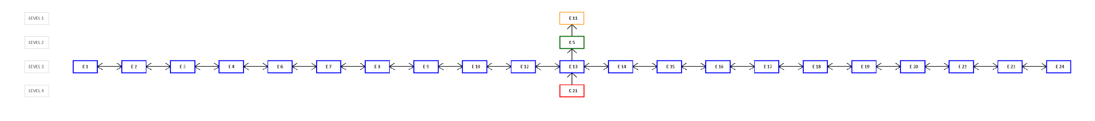

Figure 3. Structure

Based on the image above, the highest ranking can be determined, namely Market Demand (E11) as the key factor that affects the success of SMEs. Then the second rank is Own Capital (E5), and the third rank has 21 elements namely Motivation (E1), Formal Education Level (E2), Experience (E3), Entrepreneurial Spirit and Leadership (E4), Loan Capital (E6), Profit Level and Capital Accumulation (E7), Financial Governance (E8), Production Capacity (E9), Modern Technology and Quality Control (E10), Technology Selection (E12), Market Demand (E13), Competitive Pricing (E14), Promotion (E15 ), Distribution Channels and Marketing Areas (E16), Business and Investment Climate (E17), Lots of Competition in the Same Field (E18), Economic Growth (E19), Community Income Level (E20), Capital Assistance from Related Institutions (E22), There is Technical Guidance (23), Monitored and Evaluation (E24). The last ranking is Government Policy (E21).
74
3.2 Discussion
Expert Opinion
Results Expert opinion results are answers to questionnaires given by researchers to experts in answering the respective relationships between one factor and other factors. The following is an example of validating expert answers contained in table 4 to table 7 as follows:
Motivation Factor (A1) and Formal Education Level Factor (A2)
Based on tables 1 to 4 it can be seen that the answers of 4 experts regarding the relationship between motivational factors ( E1) with the factor of Level of Formal Education (E2) have different opinions. Starting from an expert from UKM Surabaya answering X which according to the expert based on the expert's own experience who is a high school graduate, as well as the work environment (employees and their relatives) in building a business, the level of one's motivation to run a business is greatly influenced by how high a person has formal education.
Then the expert from UKM Sate Pariaman answered V which according to the expert based on his work environment and experience, is a relationship between motivation and level of formal education a close relationship with each other. What the expert means is that a person's level of motivation can be triggered based on the level of formal education with the intention that the higher a person's level of formal education, the higher a person's level of motivation in running a business, but does not rule out the possibility that a low level of education hinders a person's high level of motivation. On the other hand, a person's motivation, which the expert means, is that if a person has a high level of motivation, not all of it will affect a person to improve their formal education, because people prefer to learn skills to run a business. To use Kitchen Mamamku 3B who answered V based on his experience where a person's high level of formal education will affect a person's high level of motivation to run a business. According to experts, based on basic knowledge and one's knowledge at school or college will trigger a high level of motivation for someone to run a business. And finally, according to the expert, IpatRumahMakan answered V based on the work environment and one's own experience. A person's level of formal education can be triggered based on a person's motivation. The expert intends that if a person has a high level of motivation, it will influence a person to further improve his formal education so that he is better prepared to get basic knowledge and skills in running a business.
Experience Factor (E3) and Entrepreneurial Spirit & Leadership Factor (E4)
Based on table 1 to 4 it can be seen that in the answers to the link between Experience factor (E3) and Entrepreneurial Spirit & Leadership (E4) all experts answered V which is meant the level of a person's high experience will further influence the level of entrepreneurial spirit & leadership. In other words, someone who has a lot of experience in entrepreneurship means that his entrepreneurial spirit and leadership are also high.SSIM

From the results of the questionnaires distributed there were 4 expert respondents, so this confirms that there are 4 different answers between 1 expert and another expert. To produce a Structural Self Interaction Matrix (SSIM) table, it is necessary to apply decision-making rules from various expert opinions. This is to be used to get results that represent the answers from the 4 expert answers. The decision-making rules are based on 2 consecutive provisions, including the following:
Based on the quantity the highest
In this case, if there are 2 or more of the same voices in the answer, the decision is made by choosing the voice/answer that has the quantity. For example, Expert 1 answers V, Expert 2 answers X, Expert 3 answers V, Expert 4 answers A, and Expert 4 answers O, Then the decision is made by choosing the symbol "V" which has the most votes/answers.
Based on Priority (if quantity same)
If the majority of votes have the quantity , then decision-making is based on the priority of each symbol respectively, namely:
V = first highest priority
A = second highest priority
X = third highest priority
0 = fourth highest priority.
Based on these rules, the following is one of the explanations for decision-making from the 4 expert answers into the Final using an example explanation on a comparison between the Motivation factor (A1) and other factors as follows:
Table 5. Example of SSIM Manual (A1)

 | SBY | SATE | 3B | IPAT RM | SSIM (DECISION)
A1,A2 | X | V | V | V | V
A1,A3 | X | X | X | X | X
A1,A4 | V | X | X | X | X
A1,A5 | A | V | V | V | V
A1,A6 | V | V | V | V | V
A1,A7 | A | X | X  75 | X | X
A1,A8 | X | A | A | A | A
A1,A9 | X | X | X | X | X
A1,A10 | V | V | V | V | V
A1,A11 | X | O | O | O | O
A1,A12 | V | A | A | A A | A
A1,A13 | A | A | A | A | A
A1,A14 | A | V | V | V | V
A1,A15 | X | V | V | V | V
A1,A16 | A | A | A | A | A
A1,A17 | A | X | X | X | X
A1,A18 | A | X | X | X | X
A1,A19 | O | V | V | V | V
A1,A20 | A | A | A | A | A
A1,A21 | A | A | A | A | A
A1,A22 | V | A | A | A | A
A1,A23 | A | A | A | A | A
A1,A24 | A | V | V | V | V

Based on the table above, it can be seen that for comparisons between factors Motivation (E1) with the factor of Formal Education Level (E2) has the answer with the quantity. 3 experts choose the same answer, and 1 uses a different answer, so based on the first rule, namely, priority, answer V is chosen. For the second comparison, namely, between motivation factors (E1) and experience (E3), all experts choose answer X, so the answer is chosen X. For the third comparison between Motivation (E1) and Entrepreneurial Spirit and Leadership (E4), 3 experts choose answer X out of 4 answers, then answer X is chosen, and so on.

- CONCLUSION
Based on the results of the insulation on the Rechability Matrix (Transivity rule) it can be concluded that of the 24 factors that influence the success of an UKM, it is divided into 4 levels based on the results of calculations through Driver Power & Dependent on the Rechability Matrix (RM). The highest ranking is Market Demand (E11) as a key factor influencing the success of SMEs. Then the second rank is Own Capital (E5), the third rank has 21 elements, namely Motivation (E1), Formal Education Level (E2), Experience (E3), Entrepreneurial Spirit and Leadership (E4), Loan Capital (E6), Profit Level and Capital Accumulation (E7), Financial Governance (E8), Production Capacity (E9), Modern Technology and Quality Control (E10), Technology Selection (E12), Market Demand (E13), Competitive Pricing (E14), Promotion (E15 ), Distribution Channels and Marketing Areas (E16), Business and Investment Climate (E17), Lots of Competition in the Same Field (E18), Economic Growth (E19), Level of Community Income (E20), Capital Assistance from Related Institutions (E22) , There is Technical Guidance (23), Monitored and Evaluation (E24). The last is Government Policy (E21). Referring to the ISM results, that Market Demand (E11) has a significant and directly proportional (positive) effect on the success of SMEs. Furthermore, it is found that in evaluating the products we offer, we must look at the needs of the people in that environment, what is needed, taking into account market demand.
76

- SUGGESTION
For further research, the number of experts in filling out the questionnaire should be increased by more experts so that the data is more accurate. And expanding the field of SMEs besides culinary. In this study, no statistical model validation was carried out so that in subsequent studies statistical analysis could be carried out using the SEM method.

- REFERENCES
Aryan, T.. (2021). Handling the Social and Economic Impacts Due to the Covid 19 Pandemic through the Social Entrepreneurship Approach Study: Empowering Small BusinessesMedium (SMEs). PKS Journal, Vol 20 No 1 April 2021.
Chittithaworn, C., Islam, M. A., Keawchana, T., & Yusuf, D. H. M. (2011). Factors affecting business success of small & medium enterprises (SMEs) in Thailand. Asian social science, 7(5), 180-190.
Munizu, M. (2010).The Influence of External and Internal Factors on the Performance of Micro and Small Enterprises (UMK) in South Sulawesi.Journal of Management and Entrepreneurship, pp 33-41.
Rimantho, D., & Rosdiana, H. (2017).Determination of Key Factors for Improving the Quality of Food Industry Wastewater Using Interpretative Structural Modeling (ISM).Journal of Environmental Science, pp 90-95.
Umar, I. (2021). Policy directions for controlling land use dynamics in the Antokan Watershed, West Sumatra Province. Journal of Natural Resources and Environmental Management.
Wan, J., Zhu, Y., & Liang, L. (2013).The Research on the Key Success Factors of Mobile Internet with Interpretative Structural Modeling.Scientific Research, 6.
77

